Chaitanya Bharathi Institute of Technology (CBIT), Hyderabad
Department of Computer Science and Engineering (Artificial Intelligence and Machine Learning)

SOFT COMPUTING
Case Study Report
A Genetic Algorithm-Based Hybrid Framework for Structured CNN Pruning and Knowledge Distillation for Efficient Deep Learning
Based on the research paper: “CNN Model Optimization Using a Hybrid Approach of Genetic Algorithm-based Pruning and Retraining with Knowledge Distillation” (Chou et al., GLSVLSI ’25)
Case Study Title | A Genetic Algorithm-Based Hybrid Framework for Structured CNN Pruning and Knowledge Distillation for Efficient Deep Learning
Student Name | Bheeshma Shankar
Roll Number | 160124748093
Institution | Chaitanya Bharathi Institute of Technology (CBIT), Hyderabad
Department | Computer Science and Engineering (Artificial Intelligence and Machine Learning)
Subject | Soft Computing
Academic Year | 2026–2027

Abstract
Convolutional neural networks (CNNs) give strong accuracy on vision tasks, but their large parameter counts and heavy computation make them hard to run on mobile and embedded devices. This case study analyses the paper by Chou et al. [1], which compresses CNNs by structured channel pruning guided by a Genetic Algorithm (GA). The GA encodes the pruning ratio of every layer as a chromosome and searches for a configuration that balances accuracy, parameter count and floating-point operations. After the chosen channels are removed, the pruned network is retrained with Knowledge Distillation (RKD): the original model acts as teacher, and a temperature that falls from 20 to 1 controls how soft the teacher’s targets are. The authors report that, for the largest classifier (D) of a self-distilled R(2+1)D-18 gesture model on EgoGesture, parameters fall by 91.02% and FLOPs by 90.96% with a 1.82 percentage-point accuracy drop, and inference time falls from 3.6 ms to 2.1 ms. On ResNet-32 and ResNet-56 (CIFAR-10 and CIFAR-100), RKD reaches comparable accuracy in 150 epochs instead of 200. The report also critiques the method and proposes a CIFAR-10 PyTorch experiment that has not yet been run.
Keywords: Soft Computing; Genetic Algorithm; Structured Channel Pruning; Knowledge Distillation; Model Compression; Edge AI

1. Introduction

1.1 Convolutional Neural Networks
A Convolutional Neural Network (CNN) is a neural network that learns visual patterns with small shared filters that slide over an image or a video frame. Early layers pick up edges and textures, and deeper layers combine them into parts and whole objects [7]. CNNs now power image recognition, object detection and gesture recognition, which is why the reference paper [1] treats them as the starting point for compression.

1.2 Why deep CNNs are expensive
Every convolutional layer stores one filter for each output channel, and a deep network stacks many such layers, so the parameter count quickly reaches millions. The largest classifier in the reference paper’s gesture model has 31.34 M parameters and needs 40.52 G floating-point operations (reported as |FLOP|) [1]. Each parameter takes part in many multiply–accumulate operations, so memory use, energy use and inference time all grow with model size.

1.3 Why compression matters for constrained devices
AR/VR headsets and mobile phones have limited memory and battery and need real-time responses. The authors give headsets as an example of applications with strict limits on inference time and power [1]. Making a model smaller and cheaper to run is therefore a deployment requirement, not just a convenience.

1.4 Motivation for combining GA, pruning, retraining and KD
Pruning removes parts of a trained network that contribute little. Two practical problems follow. First, choosing how much to prune in each layer is a search problem: even ten possible ratios per layer give 10^{N} combinations for N layers (analysis). Second, pruning damages accuracy, so the network needs retraining. The paper answers the first problem with a Genetic Algorithm and the second with retraining that uses Knowledge Distillation [1].
This fits Soft Computing well. A GA belongs to evolutionary computation: it keeps a population of candidate solutions and improves them through selection, crossover and mutation, instead of using gradients or trying every option. That suits pruning because the quality of a pruning configuration (accuracy, size, FLOPs) is not a smooth, differentiable function of the pruning ratios (analysis).

1.5 Purpose and scope of this case study
This report (i) analyses the reference paper [1], (ii) explains the theory behind it, (iii) restates its equations and algorithm, (iv) reviews its reported results, (v) evaluates the work critically, and (vi) proposes a CIFAR-10 experiment. No model was trained or implemented for this report. To keep sources clear, the text uses three labels: (Paper) for settings and results reported in [1], *Analysis for interpretation derived from them, and Proposed for experiments that have not been conducted. Where [1] gives no detail, the report says “Not specified in the reference paper.

2. Problem Statement and Objectives

2.1 Problem statement
Given a trained CNN with N layers, find (a) a pruning ratio for each layer and (b) a retraining procedure that together produce a smaller network whose accuracy stays close to the original while its parameters (|Param|), computation (|FLOP|) and inference time drop sharply. The difficulty is the trade-off: removing more channels saves more resources but risks a larger accuracy loss, and the number of possible per-layer ratio combinations is far too large to try one by one.

2.2 Objectives
The objectives below are measurable. The values in brackets are the results reported in [1] for its largest gesture classifier, used here as reference points (Paper).
- O1: Reduce the parameter count by about 90% or more (reported: 91.02%).
- O2: Reduce FLOPs by about 90% or more (reported: 90.96%).
- O3: Keep the accuracy drop small, at about 2 percentage points or less on the largest model (reported: 1.82 points).
- O4: Reduce measured inference latency (reported: 3.6 ms to 2.1 ms, a 41.67% reduction).
- O5: Shorten retraining compared with a label-only method such as LRW (reported: 150 versus 200 epochs on ResNets).
- O6: In the proposed student experiment, also record macro-F1 and model size for a fair comparison.

2.3 Research question and importance
Research question: Can a Genetic Algorithm that searches layer-wise channel-pruning ratios, followed by retraining with temperature-scheduled Knowledge Distillation, compress a CNN by roughly 90% in parameters and FLOPs while keeping accuracy close to the original and reducing real inference time?
Answering this matters because a smaller model that keeps its accuracy can run on a phone, a headset or an embedded board without a server, which lowers latency, energy use and dependence on connectivity.

3. Literature Review and Reference Paper Analysis

3.1 The reference paper and the problem it addresses
The reference paper is by K.-L. Chou, C.-L. Wang, Y.-C. Chen, W. Tang, Y.-T. Li, S.-C. Chang and C.-Y. Wang, published at the Great Lakes Symposium on VLSI (GLSVLSI ’25) [1]. It addresses a single question: how to reduce a CNN’s size and computation for resource-constrained devices while keeping its accuracy. The authors propose a hybrid approach that takes a well-trained model as input and returns an optimised, smaller model. The method uses a GA to find a pruning strategy, channel pruning to apply it, and retraining with knowledge distillation (RKD) to recover accuracy.

3.2 Limitations of conventional approaches discussed by the authors
The paper contrasts two kinds of pruning. Unstructured pruning [3] zeroes individual weights at arbitrary positions, which cuts the parameter count but needs special hardware support to turn into real savings. The authors show this with the R(2+1)D-18 gesture model on a HoloLens CPU: with 80% of parameters removed by unstructured pruning, inference time stayed almost the same as the original (Paper, Fig. 1). Structured pruning removes whole filters or channels [4] and is more hardware-friendly. Channel pruning methods differ in how they score importance, for example with L1 or L2 norms or a Taylor expansion [5].
For recovering accuracy after pruning, the paper reviews Fine-Tuning (FT), which retrains at a low learning rate, and Learning Rate Rewinding (LRW), which replays an earlier part of the original learning-rate schedule and is reported to give better accuracy than FT [6]. The authors argue that both minimise only the loss against the labels and ignore the original model’s output information. The paper does not discuss manual per-layer tuning in detail; its stated open challenge is finding a good balance between model size and accuracy (Paper).

3.3 Why a Genetic Algorithm?
The authors choose a GA because it can explore many candidate solutions and optimise several goals at once, which suits balancing model size against accuracy (Paper). A usual GA encodes a solution as a long string, but for a network with tens of millions of parameters that string would be huge. The paper therefore encodes one pruning ratio per layer, so the chromosome length equals the number of layers, not the number of weights.

3.4 Role of retraining and the teacher network
After pruning, the remaining weights must adapt. The paper’s retraining method, RKD, uses the original model as teacher and the pruned model as student. The student learns from the true labels and also from the teacher’s softened output probabilities. The authors argue that this keeps the finer relationships between classes that a hard label hides, since treating all wrong classes alike discards that information (Paper).

3.5 Contribution and distinguishing features
- A compact chromosome of layer-wise pruning ratios, initialised so that layers with more channels start with larger ratios, plus random noise in [−0.2, 0.2] (Paper).
- Two crossover operators (uniform and arithmetic) used on two halves of the population, with mutation and top-half selection (Paper).
- A fitness function that combines accuracy, parameter count and FLOPs, with weights α = 1, β = 4, γ = 4 (Paper).
- RKD: a weighted sum of a label loss and a KL-divergence loss, with temperature falling linearly from 20 to 1 (Paper).
- Evaluation on a video gesture model and on ResNet-32 and ResNet-56 (Paper).
Table 1. Comparison of the four approaches (the Basis column separates the paper’s statements from general comparisons).
Approach | Core idea | Strengths | Limitations | Basis
Conventional pruning | Remove weights (unstructured) or whole filters/channels (structured) with low importance [3], [4], [5] | Fewer parameters; structured form keeps dense tensors and suits standard hardware | Per-layer ratios must be chosen; accuracy drops; unstructured form gave almost no CPU speed-up (Fig. 1 of [1]) | Paper [1], Sec. 1–2
GA-based pruning | Encode per-layer ratios as a chromosome and evolve them by crossover, mutation and selection | Searches many configurations without gradients; can weigh accuracy, size and FLOPs together | Needs many fitness evaluations; extra design choices (population, rates, weights) | Paper Sec. 2.3, 3.1; cost point is general analysis
Knowledge Distillation | A student learns from the teacher’s softened outputs as well as from labels [2] | Passes on class-similarity information; can speed up recovery | Needs a teacher; adds temperature and loss-weight settings | Paper Sec. 2.4, 3.2; [2]
Combined framework | GA finds P_{best}; channels are pruned; the student is retrained with KD | Reported >90% fewer parameters and FLOPs on gesture model; RKD matched LRW-level accuracy in 150 vs 200 epochs | Only three networks tested; no ablation separating GA from KD (analysis) | Paper Sec. 3–4; limits are analysis

4. Theoretical Background

4.1 Convolutional Neural Networks
A CNN is built from a few repeated parts. A convolutional layer slides filters over its input and produces feature maps; each filter creates one output channel. An activation function, commonly ReLU, f(x) = max(0, x), adds non-linearity. Pooling shrinks the feature maps, keeping the strongest responses. Finally, fully connected layers with a softmax turn the features into class probabilities. In this report a channel is one feature map and a filter is the set of weights that produces it, so removing a filter removes its output channel.
For a convolutional layer with C_{in} input channels, C_{out} filters and a K_{h} × K_{w} kernel, the number of weights (bias ignored) and the multiply–accumulate operations (MACs) for an output map of size H_{out} × W_{out} are:
$P_{conv} = C_{out}·C_{in}·K_{h}·K_{w}$ (1)
${MACs}_{conv} = H_{out}·W_{out}·C_{out}·C_{in}·K_{h}·K_{w}$ (2)
Example (general): a layer with C_{in} = 64, C_{out} = 128, a 3 × 3 kernel and a 32 × 32 output map has 128 × 64 × 9 = 73,728 weights and 32 × 32 × 128 × 64 × 9 = 75,497,472 MACs (about 75.5 M). Both numbers scale with the channel counts, which is why removing channels cuts parameters and computation together. If a fraction p_{l} of the output channels of layer l and p_{l−1} of the layers before it are removed, the layer keeps a fraction (1 − p_{l})(1 − p_{l−1}) of its weights (analysis, Eq. 3):
$P^{'} = \left(1 - p_{l}\right)\left(1 - p_{l-1}\right)P_{conv}$ (3)
For instance, pruning 70% of the channels in every layer leaves 0.3 × 0.3 = 9% of the weights, a 91% reduction. This shows why a roughly 90% parameter cut needs only about 70% of channels removed. It is an illustration only: the paper does not report its per-layer ratios.

4.2 Structured channel pruning
Structured channel pruning removes entire channels (and their filters). Unstructured pruning instead sets single weights to zero. Figure 4 in Section 7 contrasts the two, and Table 2 summarises the difference.
Table 2. Unstructured versus structured pruning.
Aspect | Unstructured (weight) pruning | Structured (channel) pruning
What is removed | Individual weights, at arbitrary positions | Whole filters / channels (and the matching input channels of the next layer)
Tensor shape | Unchanged; the tensor becomes sparse | Smaller dense tensors
Hardware need | Sparse-aware support to gain speed | Runs on standard hardware
Latency effect | Often small (paper Fig. 1: almost no CPU speed-up at 80% removal) (Paper) | Real reduction (paper Table 1: 40.63–54.17%) (Paper)
Accuracy risk | Finer granularity, usually gentler (general) | Coarser, so a higher risk of accuracy loss (general)
The benefit of the structured form is real speed-up with no special hardware. The trade-off is that removing a whole channel is a bigger change than zeroing one weight, so accuracy can fall more and retraining is needed. To decide which channels to remove inside a layer, the paper scores their importance with a Taylor expansion [5]; the formula is not reproduced in [1], but the idea is to estimate how much the loss would change if a channel were removed.

4.3 Genetic Algorithm
A Genetic Algorithm imitates natural selection. Its parts, as used for pruning, are:
- Population and chromosome: a chromosome is one candidate solution. Here it is a vector with one pruning ratio (gene) per layer. The population is the set of M such vectors.
- Initial population: M different vectors, created from a size-aware starting ratio plus random noise.
- Fitness evaluation: a score for each vector. A higher score means a better balance of accuracy, size and computation.
- Selection: the better individuals are kept for the next generation (the paper keeps the top half).
- Crossover: two parents are mixed to make an offspring that inherits genes from both.
- Mutation: a small random change to some genes, which keeps diversity and avoids getting stuck in a local optimum.
- New generation and stopping: the steps repeat, and the search stops after a predefined number of generations (10 to 20 in the paper’s experiments).
Example (Paper, Example 1): a model with three layers has ChannelCounts = [128, 64, 256]. The chromosome [0.2, 0.32, 0.55] means 20%, 32% and 55% of the channels are pruned in layers 1, 2 and 3. That is 25.6, 20.48 and 140.8 channels, so a rounding rule is needed; the paper does not state one. Table 3 shows how the operators act on such vectors, using illustrative numbers chosen by the author.
Table 3. Illustration of GA operators on a three-layer chromosome (hypothetical numbers, not from the paper).
Operation | Setting | Result
Parents | P_{i} = [0.20, 0.32, 0.55]; P_{j} = [0.40, 0.10, 0.35] | –
Uniform crossover | selection_rate = 0.5; rand_{C} = (0.3, 0.8, 0.1) | [0.20, 0.10, 0.55]
Arithmetic crossover | r = 0.7 | [0.26, 0.254, 0.49]
Mutation | gene 2 mutates; mutation_factor = +0.05 | [0.26, 0.304, 0.49]

4.4 Knowledge Distillation
In Knowledge Distillation a large teacher network guides a smaller student [2]. A normal classifier trained on hard labels only learns “this is class 3”. The teacher’s output probabilities also say “and it looks a little like class 7”. These soft targets carry extra information. The softmax with temperature T makes them softer:
$q_{k} = \frac{exp\left(z_{k} / T\right)}{\sum_{j}{exp\left(z_{j} / T\right)}}$ (4)
Here z_{k} is the logit (raw output) for class k. A higher T gives a flatter distribution. Example (general): for logits z = [3, 1, 0.2], T = 1 gives probabilities [0.836, 0.113, 0.051], while T = 4 gives [0.475, 0.288, 0.236], so the smaller classes become visible to the student. Training combines two standard losses, cross-entropy against the true labels y and KL divergence between the softened teacher and student outputs [10]:
$CE = -\sum_{k}{y_{k} log ŷ_{k}}$ (5)
$KL(P ‖ Q) = \sum_{k}{P_{k} log \left(\frac{P_{k}}{Q_{k}}\right)}$ (6)
Eq. (4)–(6) are standard background equations. The equations that the paper itself reports are given in Section 6 and are marked as such. The distillation loss lets the student match both the labels (precision) and the teacher’s soft behaviour (richer detail), which helps it recover faster after pruning.

5. Proposed Hybrid Methodology
The framework of [1] runs in ten stages, summarised in Table 4 and drawn in Figure 1 (Section 7). Stages 2 to 6 are the GA search; stages 7 and 8 compress and recover the model; stages 9 and 10 evaluate it.
Table 4. The ten stages of the hybrid methodology (Paper, Sec. 3).
# | Stage | Purpose | Expected output
1 | Select original CNN | Provide the trained baseline whose accuracy must be kept; it also serves as the teacher | Baseline weights and accuracy
2 | Encode pruning ratios | Represent one pruning ratio per layer as a chromosome | Vector of length N
3 | Initialise population | Create M diverse candidates: size-aware starting ratio plus noise | Init = [P₁, …, P_{M}]
4 | Evaluate fitness | Score each candidate on accuracy, |Param| and |FLOP| | Fitness value per candidate
5 | Apply GA operators | Crossover (two groups), mutation and top-half selection, repeated for the set number of generations | Evolved population
6 | Select P_{best} | Take the best individual found | Best pruning vector
7 | Prune channels | Remove channels in each layer as P_{best} says, least important first (Taylor score) | Pruned (student) network
8 | Retrain with KD | Recover accuracy using the label loss plus the teacher’s soft targets | Retrained student
9 | Evaluate | Measure accuracy, |Param|, |FLOP| and inference time | Metric values
10 | Compare | Compare with the baseline (and with other methods in the paper’s tables) | Reduction and accuracy change
How the accuracy term is obtained for each GA candidate (for example, whether a candidate is briefly retrained before scoring) is not specified in the reference paper. This matters for cost and is discussed in Section 10.

6. Mathematical Formulation and Algorithm
Every equation in Sections 6.2 to 6.5 is taken from the reference paper [1]; the report’s equation number is followed by the paper’s EQ number. Table 5 defines the symbols.
Table 5. Symbols and their values (Paper, Sec. 3–4).
Symbol | Meaning | Value in paper
N, channel_{j} | Number of layers; number of channels in layer j | Model-dependent
P_{i}, pruned_{i,j} | Pruning vector of individual i; pruning ratio of layer j | Evolved by the GA
NF_{i,j} | Noise factor, uniform random | Range [−0.2, 0.2]
κ, λ | User parameters of the initial pruning ratio | κ = 150, λ = 0.2
M | Population size | Not specified in the reference paper
Generations | Number of GA generations | 10 to 20
selection_rate, rand_{C} | Threshold and random draw for uniform crossover | Rate: not specified
r | Random weight of arithmetic crossover | Distribution not specified
mutation_rate, mutation_factor, rand_{M} | Probability, size of change, and random draw for mutation | Rate and factor: not specified
Acc, |Param|, |FLOP| | Accuracy; parameter count; floating-point operations | Measured per model
α, β, γ | Fitness weights for accuracy, size and operations | α = 1, β = 4, γ = 4
z_{S}, z_{T}, T | Student logits, teacher logits, temperature | T starts at T₀ = 20
δ, E | Weight of the label loss; total retraining epochs | δ = 0.5, E = 150

6.1 Chromosome and initialisation
The channel counts of a model with N layers and the pruning vector of the i-th individual are (paper EQ 1 and EQ 2):
$ChannelCounts = \left[{channel}_{1}, {channel}_{2}, …, {channel}_{N}\right]$ (7)
$P_{i} = \left[{pruned}_{i,1}, {pruned}_{i,2}, …, {pruned}_{i,j}, …, {pruned}_{i,N}\right]$ (8)
Layers with more channels can tolerate more pruning, so the starting ratio grows with the channel count (paper EQ 4). Adding noise gives each individual a different value (paper EQ 3 and EQ 5), and the population collects M such vectors (paper EQ 6):
${Initial_Pruning_Ratio}_{j} = \left(1 - e^{-λ × \frac{{channel}_{j}}{κ}}\right)$ (9)
${pruned}_{i,j} = \left(1 - e^{-λ × \frac{{channel}_{j}}{κ}}\right) + {NF}_{i,j}$ (10)
$Init = \left[P_{1}, P_{2}, …, P_{M}\right]$ (11)
With κ = 150 and λ = 0.2, Eq. (9) gives starting ratios of 0.082, 0.157, 0.289 and 0.495 for layers of 64, 128, 256 and 512 channels (computed from the paper’s equation; Figure 6a). Eq. (10) then adds noise between −0.2 and +0.2. How a ratio that falls outside [0, 1] after noise is handled is not specified.

6.2 Crossover and mutation
The population is split into two groups: one uses uniform crossover [8] and the other arithmetic crossover [9]. In uniform crossover each gene comes from parent P_{i} if a random number rand_{C} is below selection_rate, and otherwise from parent P_{j} (paper EQ 7). In arithmetic crossover a random weight r blends the two parents (paper EQ 8):
${pruned}_{i,j}^{Offspring} = {pruned}_{i,j}^{Pi}, if {rand}_{C} < selection_rate$ (12)
${pruned}_{i,j}^{Offspring} = {pruned}_{i,j}^{Pj}, otherwise$
${pruned}_{i,j}^{Offspring} = r · {pruned}_{i,j}^{Pi} + (1 - r) · {pruned}_{i,j}^{Pj}$ (13)
For mutation, each gene draws rand_{M}. If it is below mutation_rate, the gene changes by a constant mutation_factor (paper EQ 9):
${pruned'}_{i,j} = {pruned}_{i,j} + mutation_factor, if {rand}_{M} < mutation_rate$ (14)

6.3 Fitness function and selection
The fitness value balances accuracy, model size and computation (paper EQ 10):
$Fitness = α · Acc + \frac{β}{log\left(|Param|\right)} + \frac{γ}{log\left(|FLOP|\right)}$ (15)
Here Acc is the model’s accuracy, |Param| its parameter count and |FLOP| its floating-point operations, with α = 1, β = 4 and γ = 4 (Paper). The printed equation in [1] writes the third coefficient as “r”, while the text defines it as γ; this report reads it as γ (a typographical inconsistency in the source). Because the size and operation terms are inverse logarithms, fewer parameters or FLOPs give a higher fitness, but the reward grows slowly (analysis). The log base, the scale of Acc (fraction or percent) and how Acc is measured are not specified in the reference paper. Selection ranks all individuals by fitness and keeps the top half (paper EQ 11):
$I_{current} = \left[P_{1}, …, P_{M/2}\right]$ (16)
After the final generation, the best individual is called P_{best} and is used to prune the model by channel importance (Paper).

6.4 Distillation loss and temperature schedule
The student is the pruned model and the teacher is the original model. The loss has a label part (paper EQ 12) and a distillation part (paper EQ 13), combined with a weight δ (paper EQ 14):
$Loss1 = Loss\left(Softmax\left(Output_Student\right), Target Label\right)$ (17)
$Loss2 = T^{2} × KL_div\left(Softmax\left(\frac{Output_Student}{T}\right), Softmax\left(\frac{Output_Teacher}{T}\right)\right)$ (18)
$Loss_Total = δ * Loss1 + (1 - δ) * Loss2$ (19)
The paper describes Loss1 as a traditional loss “like cross-entropy”, so Eq. (5) is its usual form. Loss2 lists the student distribution first and the teacher second; the paper does not spell out the argument convention of KL_div, and common software libraries order these arguments differently. The factor T² is the usual scaling that keeps the gradient size comparable when T changes [2] (general background). The temperature falls linearly from T₀ to 1 over the E retraining epochs (paper EQ 15), with T₀ = 20, E = 150 and δ = 0.5 (Paper); Figure 6b plots this schedule:
$T(epoch) = T_{0} - \frac{T_{0} - 1}{E} · epoch$ (20)

6.5 Algorithm
Algorithm 1: GA-Based Structured CNN Pruning and Knowledge Distillation
Input: Pre-trained CNN F, training dataset D, population size M, generations G, and retraining epochs E.
Output: Compressed and retrained CNN Fs.
- Read the number of channels in each prunable layer of F.
- Initialize the GA population:
For each individual i = 1 to M:
For each layer j = 1 to N:
init_j = 1 - exp(-lambda * channel_j / kappa)
pruning_ratio[i,j] = init_j + Uniform(-0.2, 0.2)
End For
End For
- Evaluate the fitness of each individual:
Fitness = alpha * Accuracy + beta / log(ParameterCount) + gamma / log(FLOPs)
- For each generation g = 1 to G:
  - Divide the population into two groups.
  - Apply uniform crossover to the first group.
  - Apply arithmetic crossover to the second group.
  - Apply mutation to selected genes according to the mutation probability.
  - Restrict pruning ratios to the range [0, 1].
  - Evaluate the fitness of the new candidates.
  - Rank candidates by fitness and select the top half.
  - Refill the population to size M using the chosen implementation strategy.
End For
- Select the best pruning-ratio vector P_best.
- For each prunable layer:
  - Calculate channel importance using Taylor-based scoring.
  - Rank channels from least to most important.
  - Remove the least important channels according to P_best.
  - Update dependent layers to maintain compatible dimensions.
End For
- Set the original CNN F as the teacher and freeze its weights. Set the pruned CNN Fs as the student.
- For each retraining epoch e = 0 to E - 1:
Calculate the temperature:
T = T0 - ((T0 - 1) / E) * e
For each mini-batch (x, y):
  - Compute teacher logits: zT = F(x).
  - Compute student logits: zS = Fs(x).
  - Calculate classification loss:
L1 = CrossEntropy(zS, y)

  - Calculate distillation loss:
L2 = T^2 * KL(teacher_soft_targets, student_soft_predictions)
  - Calculate total loss:
L = delta * L1 + (1 - delta) * L2
  - Update student weights using the total loss L.
End For
End For
- Evaluate the compressed model using accuracy, parameter count, FLOPs, and inference time.
- Compare the compressed model with the original CNN.
- Return the compressed and retrained CNN Fs.

6.6 Explanation with an example
Consider a CNN that classifies images into cats and dogs. Suppose it has three convolutional layers containing 64, 128, and 256 channels.

Step 1: Initialize the population
The algorithm generates candidate pruning ratios for the three layers. For example:[ P_1=[0.20,0.30,0.40] ]
This candidate proposes removing 20%, 30%, and 40% of the channels in the respective layers.

Step 2: Calculate fitness
Each candidate is evaluated using validation accuracy, parameter count, and FLOPs. A candidate that preserves accuracy while reducing model size and computation can receive a higher fitness score.

Step 3: Improve candidates using GA
Crossover combines pruning ratios from different candidates, while mutation changes selected ratios. The algorithm evaluates the new candidates and retains the better-performing ones over successive generations.

Step 4: Prune channels
Suppose the best candidate is:[ P_{best}=[0.20,0.30,0.40] ]
The resulting channel counts are:
Layer | Original channels | Pruned | Remaining
Conv1 | 64 | 13 | 51
Conv2 | 128 | 38 | 90
Conv3 | 256 | 102 | 154
These values are illustrative; actual integer counts depend on the pruning implementation.

Step 5: Apply knowledge distillation
The original CNN acts as the teacher, and the smaller pruned CNN acts as the student. For each training batch, the student learns from both the correct labels and the teacher's output probabilities.
For example, if the classification loss is 0.4, the distillation loss is 0.2, and \(\delta=0.5\):
\[ L=0.5(0.4)+0.5(0.2)=0.3 \]
The student weights are updated to minimize this combined loss.

Step 6: Evaluate the final model
Finally, compare the original and compressed CNN using:
- Accuracy: How correctly the models classify images.
- Parameter count: How many trainable values the models contain.
- FLOPs: How much computation inference requires.
- Inference time: How long each model takes to make predictions.
Expected outcome: The compressed CNN should require fewer parameters and less computation while retaining as much of the original model's accuracy as possible. Actual improvement must be verified experimentally.

7. Architecture and Figures
The figures below were drawn for this report to explain the method in [1]. They are conceptual diagrams, not copies of the paper’s figures.
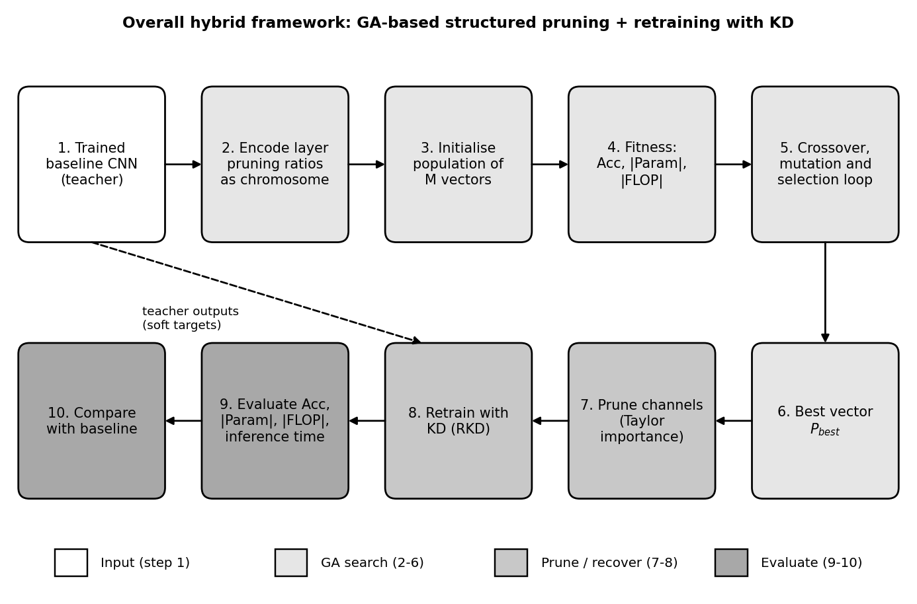
Figure 1. Overall hybrid framework, from the baseline CNN to the compared compressed model. Source: original diagram by the author, based on Sec. 3 and Fig. 4 of [1].
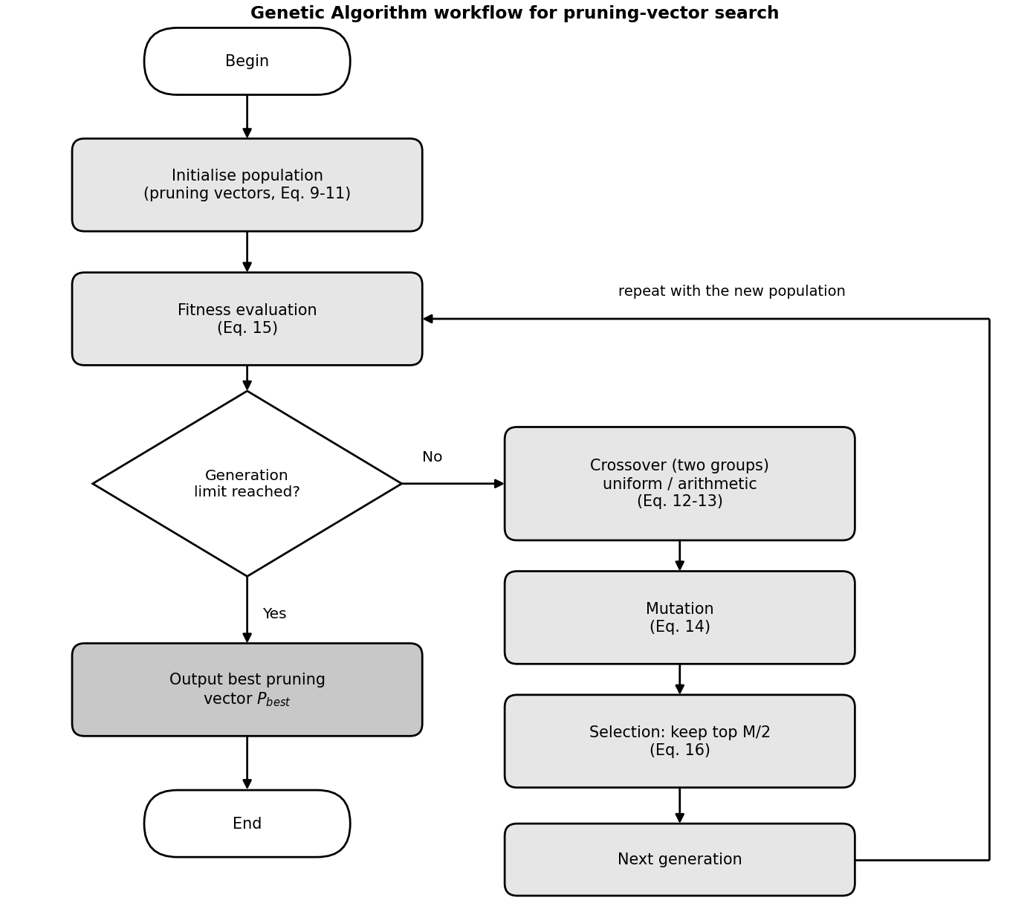
Figure 2. Genetic Algorithm workflow for searching the pruning vector. Source: original diagram by the author, based on Sec. 3.1 and Fig. 2 of [1].
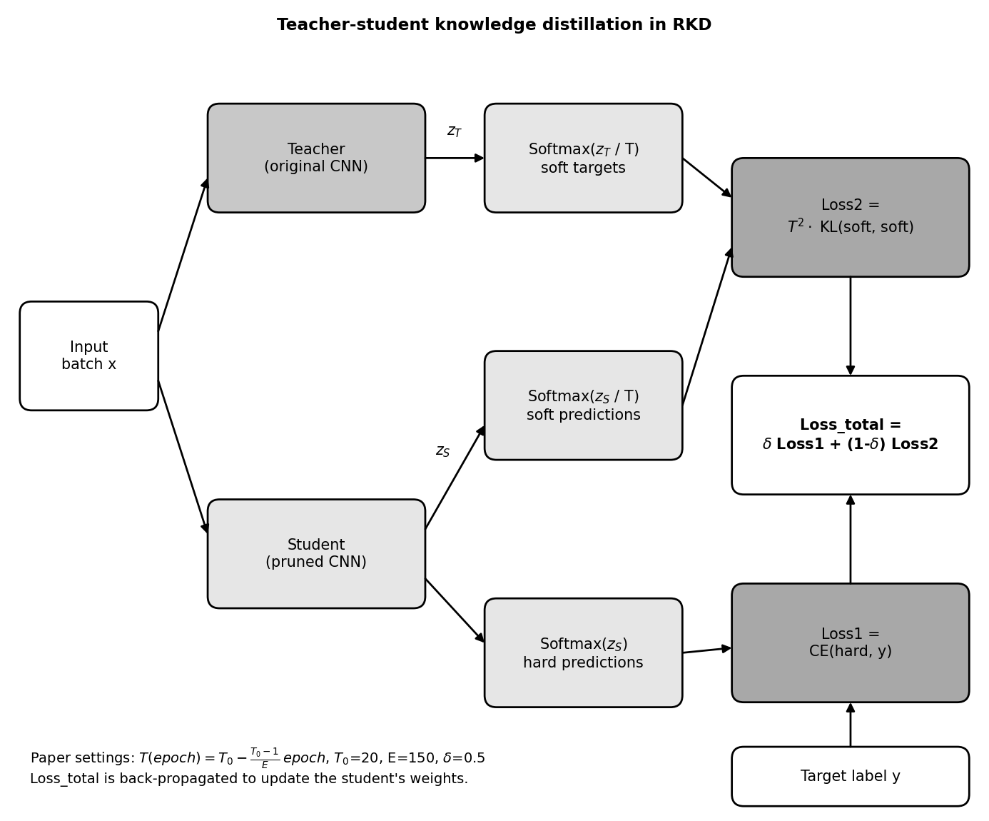
Figure 3. Teacher–student knowledge distillation used for retraining (RKD). Source: original diagram by the author, based on Sec. 3.2 and Fig. 3 of [1].
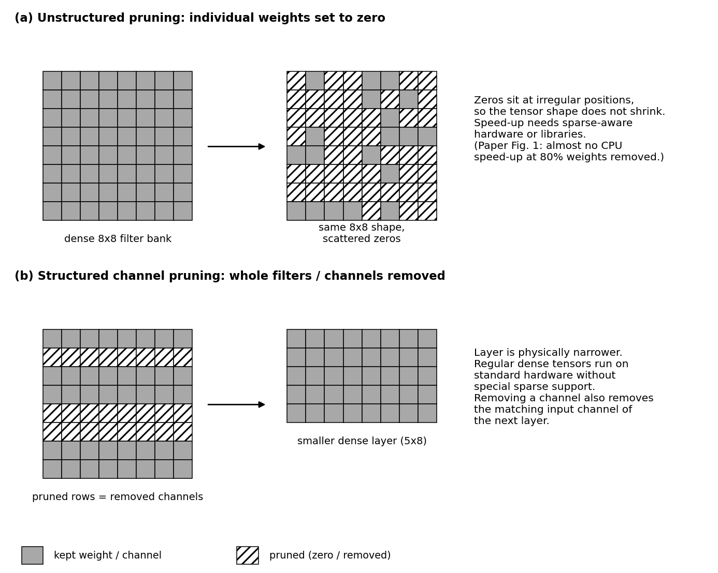
Figure 4. Structured versus unstructured pruning (conceptual illustration). Source: original conceptual diagram by the author; the HoloLens observation is from Fig. 1 of [1].
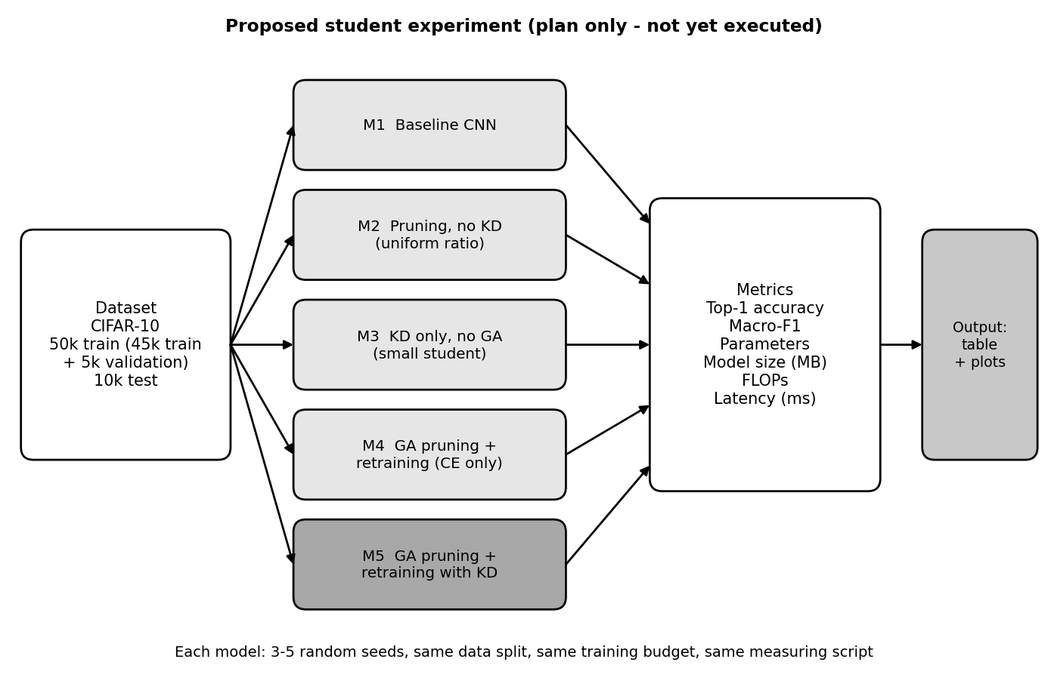
Figure 5. Proposed experimental evaluation (plan only; not yet executed). Source: original design by the author (Proposed, Section 11).
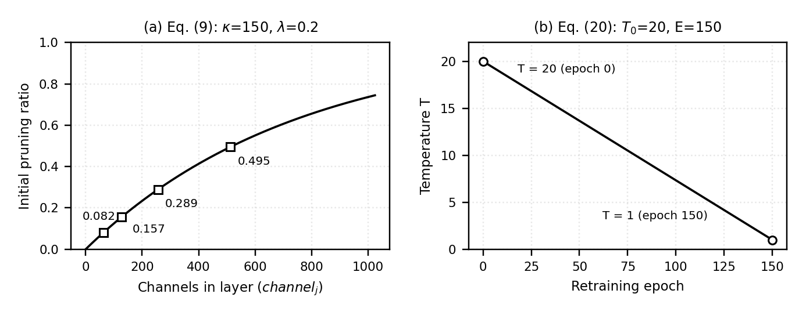
Figure 6. Computed curves of (a) the initial pruning ratio and (b) the temperature schedule. Source: computed by the author from Eq. (9) and Eq. (20) using κ, λ, T₀ and E reported in [1].

8. Experimental Setup in the Reference Paper
Table 6 lists the setup exactly as reported in Sections 3 and 4 of [1]. Items the paper does not give are marked.
Table 6. Experimental setup reported in the reference paper [1].
Item | Reported in the paper
Software | Python with the PyTorch library
Hardware | Windows 10; Intel i5-13600 CPU; NVIDIA RTX 4090; 64 GB RAM
Datasets | EgoGesture (83 hand gestures) [13]; CIFAR-10 and CIFAR-100 [14]
Architectures | R(2+1)D-18 [12] enhanced by self-distillation into four classifiers A, B, C, D (D is the largest, with the highest accuracy); ResNet-32 and ResNet-56 [11]
Initial training | ResNets: hyper-parameters from a public PyTorch CIFAR ResNet implementation cited in [1]. R(2+1)D-18: Not specified in the reference paper.
GA settings | 10 to 20 generations; κ = 150, λ = 0.2; noise in [−0.2, 0.2]; α = 1, β = 4, γ = 4; uniform and arithmetic crossover on two groups; top half kept. Population size, selection_rate, mutation_rate, mutation_factor: Not specified in the reference paper.
KD settings | δ = 0.5, T₀ = 20, E = 150, temperature falling linearly to 1
Retraining details | RKD compared with LRW (200 epochs) on ResNets. Optimiser, learning rate, batch size: Not specified in the reference paper.
Metrics | Accuracy (%), |Param| (M), |FLOP| (G), inference time (ms), and percentage reductions
Timing device | Fig. 1 timings: HoloLens CPU. Device for Table 1 timings: Not specified in the reference paper.
Other | Data splits, number of runs, random seeds, standard deviations, macro-F1, code availability: Not specified in the reference paper.

9. Results and Discussion

9.1 R(2+1)D-18 on EgoGesture
Table 7 reproduces Table 1 of [1] for the four classifiers of the self-distilled R(2+1)D-18 model. “Acc drop” is the difference in accuracy in percentage points.
Table 7. Original versus pruned R(2+1)D-18 classifiers on EgoGesture (values as reported in [1], Table 1).
Clf. | Acc (%)  orig → pruned | Acc drop (pp) | |Param| (M)  orig → pruned | |Param| ↓ (%) | |FLOP| (G)  orig → pruned | |FLOP| ↓ (%) | Time (ms)  orig → pruned | Time ↓ (%)
A | 85.09 → 77.12 | 7.97 | 1.17 → 0.11 | 90.22 | 29.28 → 2.66 | 90.92 | 2.4 → 1.1 | 54.17
B | 91.34 → 89.01 | 2.33 | 2.71 → 0.25 | 90.71 | 34.32 → 3.11 | 90.94 | 2.8 → 1.4 | 50.00
C | 92.12 → 90.14 | 1.98 | 8.73 → 0.79 | 90.98 | 38.35 → 3.47 | 90.96 | 3.2 → 1.9 | 40.63
D | 92.24 → 90.42 | 1.82 | 31.34 → 2.81 | 91.02 | 40.52 → 3.66 | 90.96 | 3.6 → 2.1 | 41.67
Source: [1], Table 1. pp = percentage points; ↓ = reduction relative to the original.
For classifier D, the paper reports accuracy of 92.24% before and 90.42% after pruning, a 1.82 percentage-point drop. Parameters fall from 31.34 M to 2.81 M (91.02% reduction) and FLOPs from 40.52 G to 3.66 G (90.96% reduction). Inference time falls from 3.6 ms to 2.1 ms. All values match Table 1 of [1] and the abstract. Every classifier loses more than 90% of both parameters and FLOPs, and inference time falls by 40.63% to 54.17% (Paper).
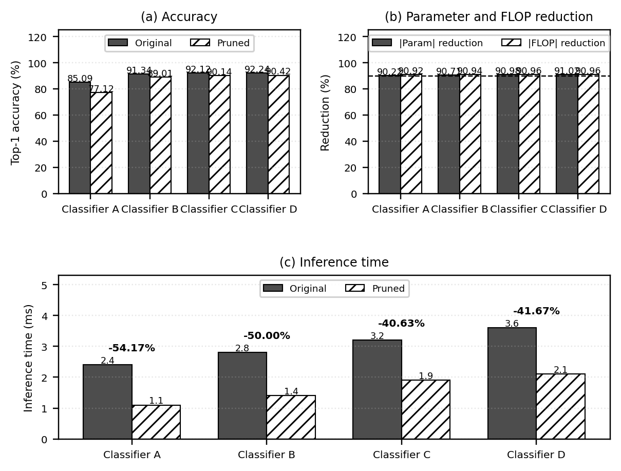
Figure 7. Reported results for classifiers A to D: (a) accuracy, (b) parameter and FLOP reduction, (c) inference time. Source: values from Table 1 of [1].

9.2 Percentage reduction versus percentage-point change
The two kinds of change are easy to confuse. A percentage reduction compares a resource before and after pruning, relative to the original value. A percentage-point change is the plain difference between two percentages, such as two accuracies:
$Reduction (\%) = \frac{X_{orig} - X_{pruned}}{X_{orig}} × 100$ (21)
$Δ_{pp} = {Acc}_{orig} - {Acc}_{pruned}$ (22)
For classifier D, Eq. (22) gives 92.24 − 90.42 = 1.82 percentage points. In relative terms this is 1.82 / 92.24 ≈ 1.97% of the original accuracy (analysis). The abstract’s “1.82% decrease in accuracy” is therefore a percentage-point figure. Applying Eq. (21), time falls by (3.6 − 2.1) / 3.6 = 41.67%, a speed-up of about 1.71×. The pruned classifier keeps about 9% of the original parameters (2.81 / 31.34 ≈ 8.97%). Recomputing from the rounded table entries reproduces the reported percentages to within about 0.1 point, except classifier A’s |Param| (recomputed 90.60% against 90.22% reported), because 0.11 M is a heavily rounded value.

9.3 ResNet-32 and ResNet-56 on CIFAR-10 and CIFAR-100
Table 8. Pruned ResNets compared with two earlier methods (values as reported in [1], Table 2).
Dataset | Model | Approach | Ori. Acc (%) | New Acc (%) | Acc drop (pp) | |Param| ↓ (%) | |FLOP| ↓ (%)
CIFAR-10 | ResNet-32 | Cheng 2023 [16] | 92.63 | 91.02 | 1.61 | – | 41.50
 |  | Cheng 2021 [15] | 92.63 | 92.14 | 0.49 | – | 53.20
 |  | Ours [1] | 92.89 | 92.17 | 0.72 | 50.43 | 58.14
 | ResNet-56 | Cheng 2023 [16] | 93.59 | 91.67 | 1.92 | – | 54.60
 |  | Ours [1] | 93.22 | 92.83 | 0.39 | 63.53 | 63.85
CIFAR-100 | ResNet-32 | Cheng 2021 [15] | 70.28 | 69.44 | 0.84 | – | 41.50
 |  | Ours [1] | 69.94 | 68.88 | 1.06 | 43.06 | 49.37
 | ResNet-56 | Cheng 2023 [16] | 71.07 | 70.73 | 0.34 | – | 52.60
 |  | Ours [1] | 71.04 | 70.69 | 0.35 | 59.93 | 62.23
Source: [1], Table 2. “–” means not reported. Rows labelled [15] and [16] are cited as [4] and [5] in the paper.
On CIFAR-10, the pruned ResNets keep accuracy within 0.72 and 0.39 points and reduce FLOPs by 58.14% and 63.85%, more than the two earlier methods’ FLOP reductions in the same table. On CIFAR-100, ResNet-32 ends slightly below [15] in accuracy (68.88% against 69.44%) but with a larger FLOP reduction (49.37% against 41.50%). For ResNet-56, the accuracy drop is 0.35 points with a 62.23% FLOP reduction, comparable to [16] (Paper).
Table 9. Retraining with RKD versus LRW [6] (values as reported in [1], Table 3).
Dataset | Model | Ori. Acc (%) | Approach | New Acc (%) | Acc drop (pp) | Epochs | |Param| / |FLOP| ↓ (%)
CIFAR-10 | ResNet-32 | 92.89 | LRW [6]  Ours | 92.02  92.17 | 0.87  0.72 | 200  150 | 50.43 / 58.14
CIFAR-10 | ResNet-56 | 93.22 | LRW [6]  Ours | 92.88  92.83 | 0.34  0.39 | 200  150 | 63.53 / 63.85
CIFAR-100 | ResNet-32 | 69.94 | LRW [6]  Ours | 68.77  68.88 | 1.17  1.06 | 200  150 | 43.06 / 49.37
CIFAR-100 | ResNet-56 | 71.04 | LRW [6]  Ours | 70.60  70.69 | 0.44  0.35 | 200  150 | 59.93 / 62.23
Source: [1], Table 3.
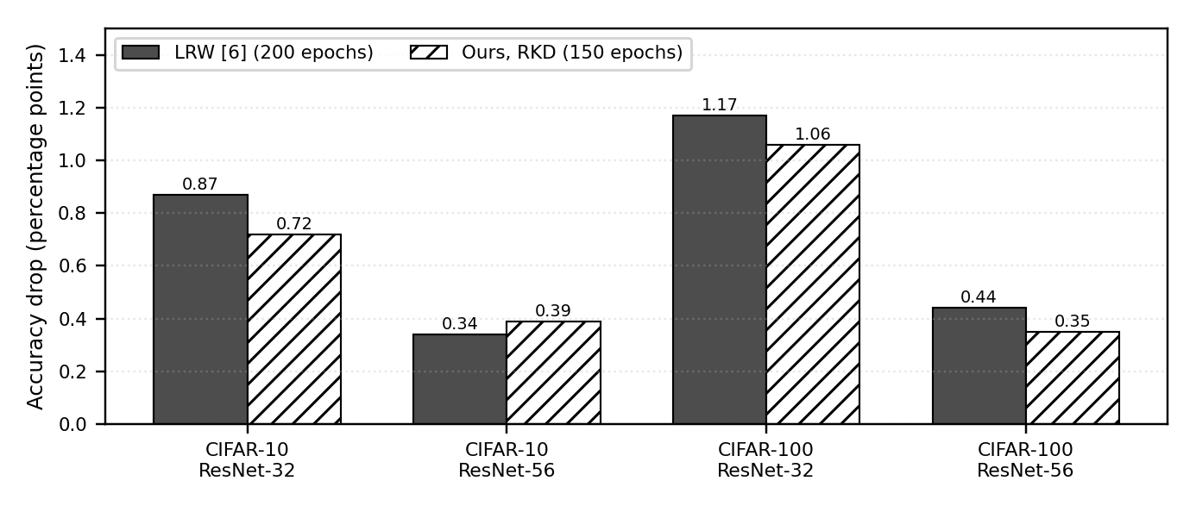
Figure 8. Accuracy drop of LRW (200 epochs) and the proposed RKD (150 epochs). Source: values from Table 3 of [1].
RKD reaches an accuracy drop similar to LRW in 150 epochs instead of 200, which is 25% fewer epochs. It is slightly better in three of the four settings and slightly worse for ResNet-56 on CIFAR-10 (0.39 against 0.34 points) (Paper).

9.4 What the results imply
Together, the results support the paper’s claim that the hybrid method can remove about 90% of a large gesture model’s parameters and FLOPs with a modest accuracy loss, and can recover accuracy faster than a label-only retraining method. Two patterns stand out (analysis). First, the smaller classifiers lose much more accuracy (7.97 points for A against 1.82 for D), so the trade-off depends on the size of the original model; a likely reason is that smaller models have less redundancy, but the paper does not test this. Second, inference time falls by only about 41% for D although FLOPs fall by about 91%, so FLOP savings do not translate one-to-one into speed.

10. Critical Evaluation
Strengths. The method targets structured pruning, so its savings can show up as real speed-up on ordinary hardware. The chromosome is compact (one gene per layer), which keeps the GA tractable even for models with tens of millions of parameters. The fitness function weighs accuracy, size and computation together, and the retraining method reached comparable accuracy in 25% fewer epochs than LRW. The method was tried on a video model and two ResNets (Paper).
Cost of the GA search. Each candidate needs a fitness evaluation, so the search costs roughly population size × generations evaluations (analysis). The paper reports 10 to 20 generations but not the population size, search time or whether candidates are retrained before scoring, so the true cost cannot be judged.
Accuracy degradation and retraining cost. Pruning always costs some accuracy: 1.82 points for classifier D, but 7.97 points for classifier A, which may be unacceptable. RKD also needs up to 150 epochs of retraining plus a forward pass through the teacher at each step (analysis), so compression is cheaper to run than to produce.
Dependence on the teacher. The student inherits the teacher’s mistakes and is limited by its quality. Here the teacher is the original model, which is convenient, but the paper does not test other teachers (analysis).
Dataset and architecture dependence. Results cover three networks on EgoGesture, CIFAR-10 and CIFAR-100. The gains on other tasks, such as detection, or on other networks, such as transformers, are untested.
Fewer FLOPs do not guarantee proportional speed. For classifier D, FLOPs fell 90.96% but time fell only 41.67%. Memory traffic, layer overheads, small layers that under-use the processor and the measuring setup can all limit speed-up; the paper does not explain the gap (analysis).
Inconsistencies and comparison limits. The text of Sec. 4.1 says the pruned model keeps more than 90.00% accuracy, but Table 1 shows 77.12% and 89.01% for classifiers A and B. The comparison with [15] and [16] uses different original accuracies (for example 92.89% against 92.63% for ResNet-32 on CIFAR-10), and their parameter reductions are not reported, so the comparison is not fully controlled. No standard deviations or repeated runs are reported.
Missing ablation. Table 9 compares RKD with LRW, which differ in both loss and learning-rate schedule. The paper does not compare GA-found ratios with uniform or random ratios, so the benefit of the GA itself, and the separate effect of distillation, are not isolated (analysis).
Deployment and reproducibility. Real deployment also depends on the target hardware, the accepted accuracy loss, and combination with other methods such as quantisation. Reproducing the work is hard because the paper omits population size, selection and mutation settings, FLOP-counting convention, the log base and Acc scale in the fitness, training details for R(2+1)D-18, and data splits (Section 8).

11. Proposed Student-Level Implementation
This section is a proposed implementation plan. No code has been executed and no results exist. The design choices below are the author’s own and are not taken from [1] unless stated.

11.1 Setup
- Dataset: CIFAR-10 [14]. Split the 50,000 training images into 45,000 for training and 5,000 for validation; keep the 10,000 test images untouched until the final evaluation. The GA fitness uses only the validation split.
- Baseline CNN and teacher: a VGG-style network with six 3 × 3 convolutional layers (64, 64, 128, 128, 256, 256 channels) with batch normalisation, ReLU and max-pooling, followed by a small classifier. A plain network is chosen because pruning channels is simpler without residual connections; ResNet-32, used in [1], is an optional extension.
- GA settings (starting values): κ = 150, λ = 0.2, α = 1, β = 4, γ = 4, δ = 0.5 and T₀ = 20 as in [1]; population size 20 and 10 to 20 generations as the author’s choice; ratios clipped to a safe range, which [1] does not specify. Each candidate is scored on the validation split after a short fine-tune (a design choice).
- Framework: Python and PyTorch [17].
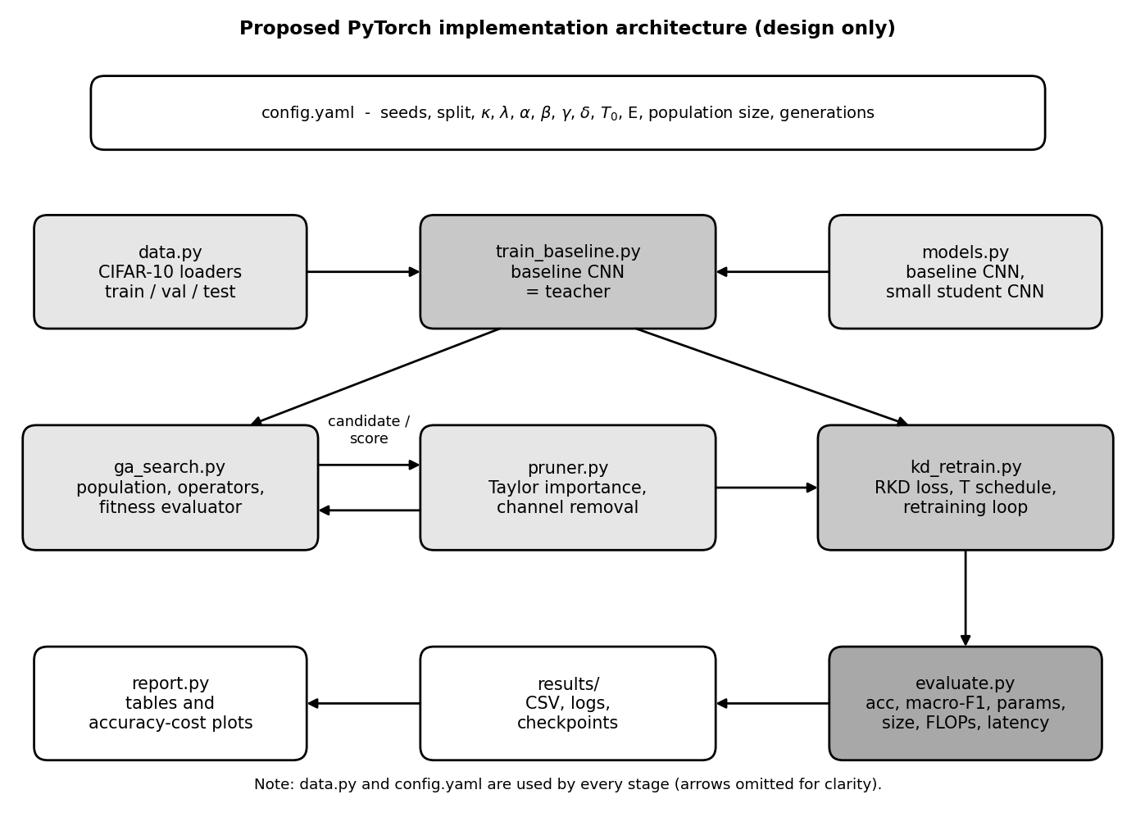
Figure 9. Proposed PyTorch implementation architecture. Source: original design by the author (Proposed; not implemented).

11.2 Planned comparison
Table 10. Proposed experimental table (all result cells are left empty on purpose).
ID | Configuration | Top-1 acc (%) | Macro-F1 | |Param| | Size (MB) | FLOPs | Latency (ms)
M1 | Original CNN baseline | To be measured | To be measured | To be measured | To be measured | To be measured | To be measured
M2 | Pruning without KD (uniform ratio, Taylor importance, label-loss retraining) | To be measured | To be measured | To be measured | To be measured | To be measured | To be measured
M3 | KD without GA pruning (small hand-designed student with the same parameter budget as M5) | To be measured | To be measured | To be measured | To be measured | To be measured | To be measured
M4 | GA-based structured pruning with retraining (label loss only) | To be measured | To be measured | To be measured | To be measured | To be measured | To be measured
M5 | GA-based structured pruning with retraining and KD (RKD) | To be measured | To be measured | To be measured | To be measured | To be measured | To be measured
Comparing M2 with M4 shows the value of the GA; comparing M4 with M5 shows the value of KD; comparing M3 with M5 shows whether pruning a large network beats training a small one with KD.

11.3 Measurement plan
- Accuracy and macro-F1: top-1 accuracy on the test set; macro-F1 is the unweighted mean of the ten per-class F1 scores, computed with scikit-learn.
- Parameters and model size: count the parameters of the model and report the saved weight file in MB.
- FLOPs: use a profiler such as fvcore or ptflops, and state whether the tool reports MACs or FLOPs, since [1] does not state its convention.
- Latency: batch size 1; 50 warm-up runs; at least 300 timed runs; report the median; fix the CPU thread count; call torch.cuda.synchronize() on GPU. Measure on the same machine for all models.

11.4 Reproducibility and fair comparison
Run every configuration with five random seeds (for example 0 to 4) and report the mean and standard deviation. Fix the data split, augmentation and training budget for all configurations; M4 and M5 should use the same number of retraining epochs so that only the loss differs. Enable deterministic PyTorch settings where possible. For each run, save the configuration file, seed, GA fitness per generation, and all metrics to a CSV file, and keep the code in a version-controlled repository.

12. Applications, Advantages, and Limitations
A smaller, faster CNN is useful wherever compute, memory or power is limited. Possible settings include mobile vision, embedded systems, AR/VR gesture recognition (the setting evaluated in [1], with HoloLens timings in its Fig. 1), edge AI cameras and sensors, and robots or drones. Only the gesture and CIFAR experiments were run in [1]; the method has not been validated for every application listed here.
Table 11. Advantages and limitations of the hybrid approach.
Advantages | Limitations
Structured pruning gives real speed-up on standard hardware (Paper) | GA search needs many fitness evaluations; its cost is not reported (analysis)
More than 90% fewer parameters and FLOPs for the gesture model with a 1.82-point drop for classifier D (Paper) | Accuracy loss can be large for small models (7.97 points for classifier A) (Paper, Table 1)
Compact chromosome (one gene per layer) scales to large models (Paper) | Several settings are unspecified, which limits reproducibility (Sec. 8)
RKD reached comparable accuracy in 150 instead of 200 epochs (Paper) | Needs a trained teacher and a long retraining stage (analysis)
Balances accuracy, size and computation in one fitness (Paper) | Fewer FLOPs do not guarantee proportional speed (Paper, Table 1)

13. Conclusion and Future Scope
Deep CNNs are accurate but costly to store and run, which makes them hard to deploy on constrained devices. The reference paper [1] proposes a hybrid solution: a Genetic Algorithm searches one pruning ratio per layer, the chosen channels are removed, and the pruned network is retrained with Knowledge Distillation from the original model.
The evolutionary search replaces manual tuning of layer-wise ratios with a population-based search guided by a fitness that weighs accuracy, size and operations. Knowledge Distillation lets the pruned network learn from the teacher’s soft outputs as well as from the labels, with a temperature that falls from 20 to 1. The paper reports that its largest gesture classifier lost 91.02% of its parameters and 90.96% of its FLOPs for a 1.82 percentage-point accuracy drop, with inference time falling from 3.6 ms to 2.1 ms, and that RKD matched LRW-level accuracy on ResNets in 150 rather than 200 epochs.
Challenges remain. The GA’s search cost and several settings are not reported, smaller models lose far more accuracy, speed-up is much smaller than the FLOP reduction, and the separate contributions of the GA and of distillation are not isolated. Future work could add an ablation against uniform or random ratios, report search cost, run repeated trials, test on more architectures and tasks, measure latency on real target devices, and combine the method with quantisation. The proposed CIFAR-10 plan in Section 11 is a first step towards testing these questions.

References
[1] K.-L. Chou, C.-L. Wang, Y.-C. Chen, W. Tang, Y.-T. Li, S.-C. Chang, and C.-Y. Wang, “CNN model optimization using a hybrid approach of genetic algorithm-based pruning and retraining with knowledge distillation,” in Proc. Great Lakes Symp. VLSI (GLSVLSI ’25), New Orleans, LA, USA, Jun. 30–Jul. 2, 2025, pp. 667–672, doi: 10.1145/3716368.3735193.
[2] G. Hinton, O. Vinyals, and J. Dean, “Distilling the knowledge in a neural network,” arXiv:1503.02531, 2015.
[3] S. Han, J. Pool, J. Tran, and W. J. Dally, “Learning both weights and connections for efficient neural networks,” in Proc. NeurIPS, 2015.
[4] Z. Liu, J. Li, Z. Shen, G. Huang, S. Yan, and C. Zhang, “Learning efficient convolutional networks through network slimming,” in Proc. ICCV, 2017, pp. 2736–2744.
[5] P. Molchanov, S. Tyree, T. Karras, T. Aila, and J. Kautz, “Pruning convolutional neural networks for resource efficient inference,” arXiv:1611.06440, 2016.
[6] A. Renda, J. Frankle, and M. Carbin, “Comparing rewinding and fine-tuning in neural network pruning,” in Proc. ICLR, 2020.
[7] Y. LeCun, L. Bottou, Y. Bengio, and P. Haffner, “Gradient-based learning applied to document recognition,” Proc. IEEE, vol. 86, no. 11, pp. 2278–2324, 1998.
[8] G. Syswerda, “Uniform crossover in genetic algorithms,” in Proc. Int. Conf. Genetic Algorithms (ICGA), vol. 3, 1989.
[9] O. Köksoy and T. Yalcinoz, “Robust design using Pareto type optimization: A genetic algorithm with arithmetic crossover,” Comput. Ind. Eng., vol. 55, no. 1, pp. 208–218, 2008.
[10] S. Kullback and R. A. Leibler, “On information and sufficiency,” Ann. Math. Statist., vol. 22, no. 1, pp. 79–86, 1951.
[11] K. He, X. Zhang, S. Ren, and J. Sun, “Deep residual learning for image recognition,” in Proc. CVPR, 2016, pp. 770–778.
[12] D. Tran, H. Wang, L. Torresani, J. Ray, Y. LeCun, and M. Paluri, “A closer look at spatiotemporal convolutions for action recognition,” in Proc. CVPR, 2018, pp. 6450–6459.
[13] Y. Zhang, C. Cao, J. Cheng, and H. Lu, “EgoGesture: A new dataset and benchmark for egocentric hand gesture recognition,” IEEE Trans. Multimedia, vol. 20, no. 5, pp. 1038–1050, 2018.
[14] A. Krizhevsky and G. Hinton, “Learning multiple layers of features from tiny images,” Univ. Toronto, Toronto, ON, Canada, Tech. Rep., 2009.
[15] H. Cheng, Z. Wang, L. Ma, X. Liu, and Z. Wei, “Multi-task pruning via filter index sharing: A many-objective optimization approach,” Cogn. Comput., vol. 13, no. 4, pp. 1070–1084, 2021.
[16] H. Cheng, Z. Wang, L. Ma, Z. Wei, F. E. Alsaadi, and X. Liu, “Differentiable channel pruning guided via attention mechanism: A novel neural network pruning approach,” Complex Intell. Syst., vol. 9, no. 5, pp. 5611–5624, 2023.
[17] A. Paszke et al., “PyTorch: An imperative style, high-performance deep learning library,” in Proc. NeurIPS, 2019.
Reference [1] is the primary source and was read in full for this report. References [2]–[16] are works cited by [1] and are listed as secondary sources for background; [17] is cited for the proposed implementation. Venue details of [11] and [12] follow the original publications.

Appendix A: Glossary
Term | Meaning
Channel / filter | One feature map of a convolutional layer / the weights that produce it
Structured pruning | Removing whole channels or filters, so the layer becomes smaller
Unstructured pruning | Setting individual weights to zero, leaving the tensor shape unchanged
Chromosome / gene | A candidate solution / one element of it (here, one layer’s pruning ratio)
Fitness | Score that tells the GA how good a candidate is
Crossover / mutation | Mixing two parents / randomly changing genes
Teacher / student | The original, larger model / the smaller pruned model that is trained
Logit | Raw output of the last layer before softmax
Temperature (T) | Value that softens (T > 1) the softmax output
KL divergence | Measure of how different two probability distributions are
FLOP / MAC | Floating-point operation / multiply–accumulate operation
RKD | Retraining with Knowledge Distillation, the retraining method of [1]
LRW / FT | Learning rate rewinding / fine-tuning, label-only retraining methods [6]

Appendix B: Numerical Verification Log
Item checked | Location in [1] | Result
Classifier D: 92.24 → 90.42 %, drop 1.82 | Table 1; Sec. 4.1; abstract | Matches
Classifier D: 31.34 → 2.81 M (91.02%); 40.52 → 3.66 G (90.96%) | Table 1; abstract | Matches
Classifier D: 3.6 → 2.1 ms | Table 1 | Matches (41.67%)
Classifiers A–C values | Table 1 | Matches; drops re-computed
ResNet results and RKD vs LRW | Tables 2 and 3 | Matches; drops re-computed
κ, λ, α, β, γ, δ, T₀, E, noise range, generations | Sec. 3.1, 4 | Matches
“More than 90.00% accuracy after pruning” | Sec. 4.1 | Inconsistent with Table 1 (A: 77.12%, B: 89.01%)
Third fitness coefficient printed as “r” | Sec. 3.1.4, EQ 10 | Read as γ (typographical inconsistency)

